Name___________________________ M. Lewis Homework Nov. 3-6 Due: Dec. 7
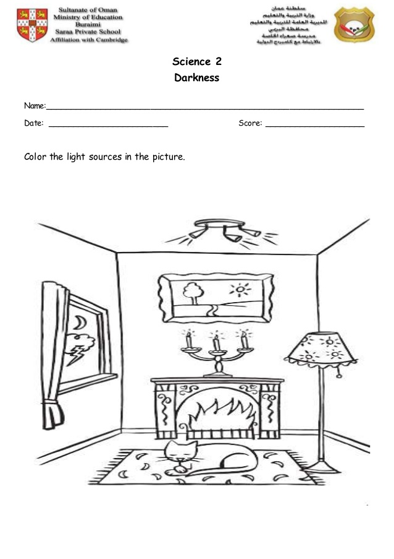
Use the picture below to answer questions 1-4.

Monday:
- Circle at least two sources of man-made, or artificial light.

Tuesday:
- Circle at least two sources of natural light.
Wednesday:
- Which source of light in the living room do you think is producing, or making the most amount of heat? ________________________________________________________
Thursday:
- If the curtains were closed, would it darken or brighten the room? Why?
________________________________________________________________________________________________________________________________________________

