Budget Activity
In the United States, we have a free enterprise system. This means we can choose how we earn money and how we spend it.
Monday, April 1:
- Let’s pretend you have $20 to spend. Look at the items below. Choose 2 things that you need. Write the names of the items, their prices and the total amount you spent.

Name of the item | Cost
Total
Tuesday, April 2:
How much money do you have left? _____________________
If you have money left, you have 2 choices. Do you want to save it or spend it? _____________________________________________________________________________
Wednesday, April 3:
If you plan to spend it, what will you spend it on?
_____________________________________________________________________________
Thursday, April 4:
Which item will you have to save for because it is greater than $20.00? _____________________________________________________________________________
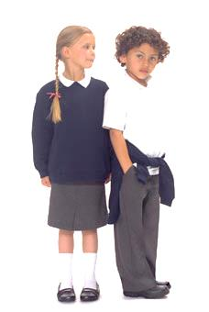  An Outfit for School $10  Cereal $3 | Puppy  $10  American Girl Doll $30 | 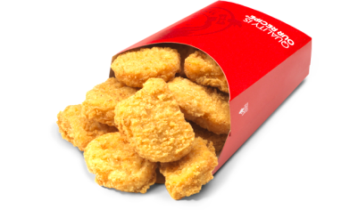  Chicken Nuggets  $5  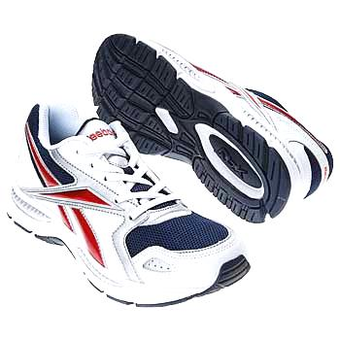  Shoes for School $15

