M. Lewis Homework January 14-17 Due: January 18, 2019 Past, Present, Future
Long ago and today
Monday, January 14, 2019
- Choose the item that represents something from the past and circle it.
Tuesday, January 15, 2019
- Choose the item that represents something from the present and circle it.

- Wednesday, January 16, 2019
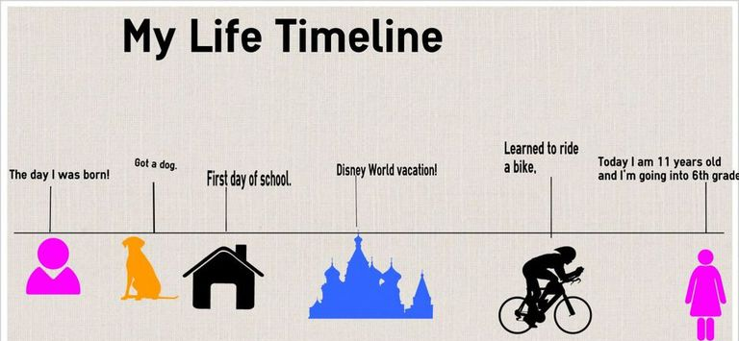
Look at the timeline above. How old was the little girl when she became a 6th grader?

- Thursday, January 17, 2019
Which event happened in the life of the young girl before she went to Disney World? ____________________________________________________________________

