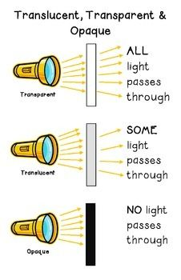
Name______________ M. Lewis Homework Jan.7-10 Due: Jan. 11
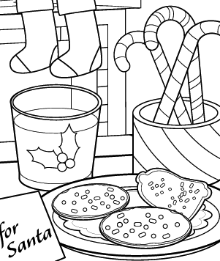
Use the pictures below to answer questions 1-4.

Monday:
- Circle the item that is completely transparent, and all light passes through it.

Tuesday:
- Color at least two opaque objects that no light can pass through.
Wednesday:
- Which item might be translucent if held up to light? ________________________________________________________
Thursday:
- Why is it better for the stockings hung on the fireplace to be opaque instead of transparent?
________________________________________________________________________

________________________________________________________________________

