M. Lewis Patterns in Nature Homework March 11-14 Due: March15
Source 1: The Four Seasons Source 2: Seasonal Patterns of Sunrise and Sunset
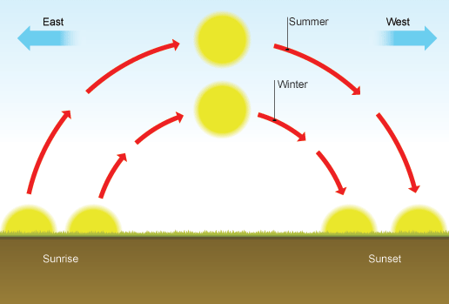
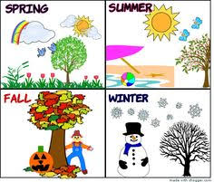
Monday, March 11, 2019
- Look at source 1, which season is the coldest? _________________________
- Look at source 1, which season is the hottest ? __________________________
- Look at source 1, which season do the leaves begin to fall off of the trees? ____________________
Tuesday, March 12, 2019
- Look at source 2, which season has more daylight, winter or summer? __________________
- Look at source 2, which season has less daylight from sunrise to sunset? ____________________
Wednesday, March 13, 2019
- In the winter we receive less sunlight, how does this impact the weather?
_____________________________________________________________________________________
Thursday, March 14, 2019
- How does the amount of sunlight effect plant life on Earth?
_____________________________________________________________________________________
Source 3: Louisiana Sugar Cane Crop in Snow Source 4: Louisiana Sugar Cane Crop in the Summer
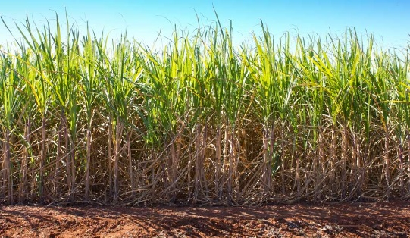
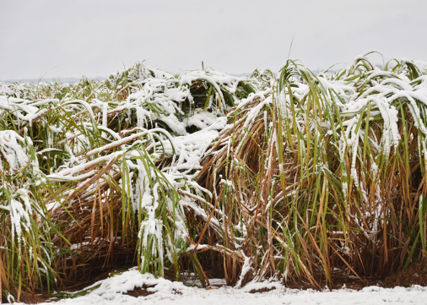

- Compare source three and four. Which crop looks healthier? How does the weather effect our local sugar cane farmers and their crops? ______________________________________________________________________________

