M. Lirette Homework American Symbols November 26-29 Due: November 30

Monday, November 26, 2018 : Use source 1 and 2 to answer the questions below.
Source 1: The White House Source 2: The United States Flag
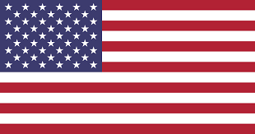
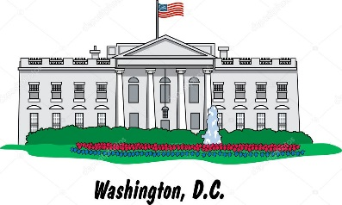
- The president lives in the ____________________________.
- The _______________________________ has 50 stars that represent the fifty states.
Tuesday, November 27, 2018: Use source 1 and 2 to answer the questions below.
- The _____________________________ has red and white stripes.
- The _____________________________ is where the president gives a lot of speeches.

Source 3: The bald eagle Source 4: The Statue of Liberty
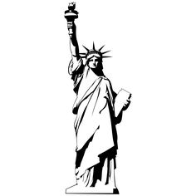
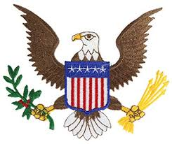

Wednesday, November 28, 2018: Use source 3 and 4 to answer the question below.
- The ____________is a strong bird that can fly high in the sky.
- The _____________________holds a torch that represents the light of freedom.
Thursday, November 29, 2018
Which American symbol is your favorite and why?

