Name ________________________________________________ Date __________________
Engineering Process
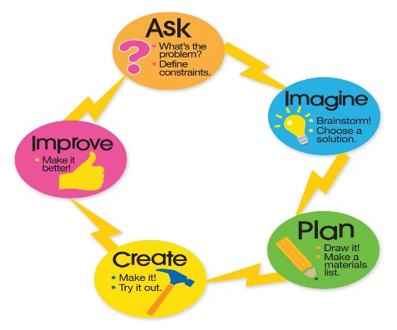
Jeff plans to learn more about earthquakes by experimenting with cups to make a model of a tall tower. He’s going to follow the steps of the engineering process:
Make a plan.
Ask a question.
Create the experiment.
Improve the experiment.
Imagine all your steps.
Monday, October 15
Sadly, Jeff mixed up the steps. Help him out by rewriting the steps in the correct order.
1) ________________________________________________________________
2) ________________________________________________________________
3) ________________________________________________________________
4) ________________________________________________________________
5) ________________________________________________________________
Tuesday, October 16
Brad loves to eat chocolate bars. He takes one with him each day in his lunch. Unfortunately, it usually melts before lunch. (2 pts)
Finish the question that Brad could ask to help him investigate why his candy bars keep melting.
6. What can be wrapped around chocolate to keep it from ____________________?
Wednesday, October 17
7. Maria want to know why some objects can hold up more weight than others. She makes a plan, creates a model building, and watches as it falls. Her test failed. Circle her next step?
- Make a plan b. Create a model c. reflect and improve d. she’s done
Thursday, October 18
8. Maria decided to reflect and improve her work. She realized that she did not make the bottom of her model wider than her top. She tries this and it works. Her building can hold a lot of weight. Did Maria correctly complete the engineering process using all five steps above?
Circle the correct response: Yes No

